PROJECT PROPOSAL

Majorel | Tech Hub 4, SM Clark, Angeles, Pampanga

proponent

Mark GIDION Enojado

2020

Majorel  
Horizone srt tool

February 28, 2020

# Overview

## Project Background and Description

The purpose of this project proposal is to increase the site’s accuracy scores and to improve the wellbeing of the reviewers. The proponent will develop a tool to help reviewers reduce their blatant errors.

## Situation, Task Action Result Model

**Situation**

The reviewers are not hitting the accuracy target set by the client because of failed taggings. There are reasons why the reviewer misses the tagging for a specific job. The first one is Knowledge Issue which is the reviewer didn't label the job because there is a gap between the reviewer and the policy (Wiki) or the recent updates. Second is the Grey Area wherein the reviewer failed to tag the job because the violation seen in the component is new and no one has ever encountered them before or probably a confusion with the policy. In the present, most of them occurred because of blatant errors. Blatant errors are labels / violations which is explicitly seen in the job component but the reviewer didn't label it. This is not a skill issue where you have a knowledge gap in the standard policies but a will of the reviewer.

**Probable reasons for getting blatant errors.**

* Loss of focus.
* Didn’t review the tagging tree.
* There is too much to read.
* Scanning the contents of the job.

**Task**

There are certain targets that the reviewer should met in Globa Protocol. We call it "Score Card" it contains Attendance, Blatant, QA Score, Accuracy Score and Utilization. The most important one among them is the accuracy score, to measure how a reviewer can tag a specific job accurately. It is important because the client expect us to get an accuracy score of 90% and above. We know that blatant errors are one of the reasons to consider that is preventing us to meet the target accuracy score. That’s why the proponent main task is to reduce the blatant errors of the reviewer and if possibly eliminate them.

**Action**

* **The propenent action is to design, develop and implement a tool that will help reviewers to reduce their blatant errors.**

To design, develop and implement a Highlighter tool that predicts the possible labels for a job base on keywords. The tool will scan the whole web page for possible labels and display it on home tab of the highlighter tool. It also shows the possible label for each Government Body, Position, Elections, Vote for and GOTV for the user to visualize why the tool highlighted the word / possible label. The users can also add their own keywords.

**Result**

With the help of this tool the proponent expects to reduce the explicitly blatant error from the reviewers.

## Scope

* Highlighter Tool
* Text to speech
  + It reads the component for the reviewer.
* Miscellaneous
  + Auto Tagging Tree
  + Sticky Tagging Tree
  + Timer with logger

## Requirements

* Web Browsers (Google Chrome, Mozilla etc.)
* Web Hosting
* Google Developers Account

## Screenshots

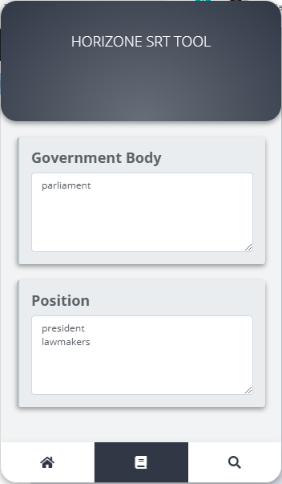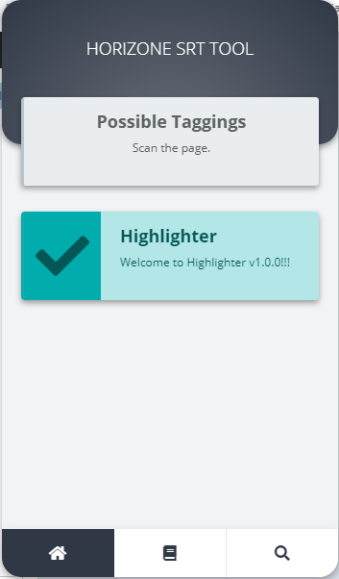

## SRT TOOL DEMO

